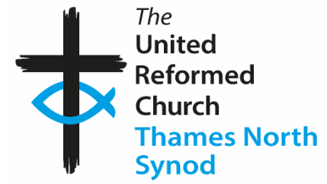 Hounslow URC July/August ’26 Newsletter 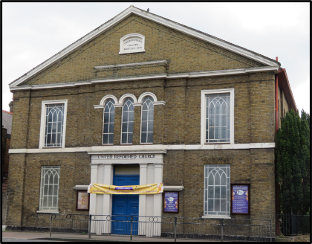
Hello everyone,
Family news
Please continue to pray for Kar Geh, Shirley, Mabel, Rachel (John’s wife) and her family. Also, Bernard and Liz.
Gill Gowers (1928-2026) by Wendy McTernan - Gill’s daughter
Gill recently passed away peacefully at the age of 97. She had been an active member of Hounslow URC for 60 years, until moving to the Cotswolds in 2018.
When we moved to Hounslow in 1955 Gill saw a card in the butcher's shop window advertising a ‘Friendship Club’ at the Congregational Church. Thinking this might be a way to make some friends, she went along, and soon we started attending the church as a family. In time, Gill became the Club’s leader, for some 12 years.
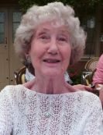
Helping with things like jumble sales in the early days, and joining in with social and sporting activities, Gill eventually became a church Elder, visiting people who were ill or housebound as part of her duties. Another task she took on willingly for many years was as Pulpit Secretary. For five years she was Chair of ‘Churches Together’ in Hounslow.
As well as being part of the church, my mother was also active in the local community, and is much missed by her neighbours in Holly Road.
Flowers on Sunday 26th July will be in memory of Gill whose birthday falls on the 27th.
John’s Memorial
We are going to collect to buy a shrub for the garden in memory of John. This may have to wait until next year if it is the wrong time to plant. We will ask for contributions soon. There will also be a booklet to include all your tributes to him.
Services for July, August and September
12th July – Rev. Andrew Heron 26th July – Rev. Ian Gow (H.C.)
Flowers in memory of Gill Gowers
9th August – Margaret Johnson 23rd August - TBC
Other dates for your diary (reminders):
Elders’ Meetings: 12th July, 9th August, 11th October, 8th November, 13th December
Church Meetings: 13th September
Other Dates
Sunday 23rd August – Church tidy up and BBQ
Sunday 11th October – Harvest and shared lunch
Future Services
You will see from the above schedule that we have gaps without a designated preacher. At our recent AGM we discussed this and decided that all willing members of the Congregation could take a more active part. Several people said that they would like to have a bible study as part of or instead of a service. We will be looking at available publications (printed or online) to move this forward. Any offers of help, or names of possible preachers to ask would be appreciated.
Best wishes to all,
Jane

1926 – General Strike (4th- 12th May) – by Tony Fredjohn
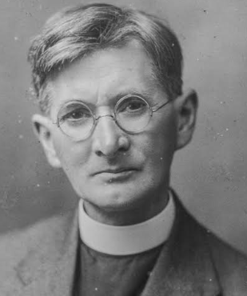
The event already mentioned (on 9th May this year) was organised by the Local Trades Council (who now meet in our premises. They arranged a walk locally from Bell Road to Hounslow Bus Garage and back to the church. Here they had a recognition meeting/celebration. This included a display, a talk and some refreshments. The role of this church was mentioned and a picture of the minister (Rev. Hugh Walker) was displayed along with his biography (which can still be viewed in the church).

Rev. Hugh Walker
After consulting the Finance Report Book this was stated:
27/5/1926 – “We as a body recommend to the church, that the sum of 10/-, donated to us by the Union branch, in payment for the use of Church House (in Douglas Road), be submitted to a fund for the relief of the miners’ children. Some men on strike attended the church service and the offertory was much increased.”
Deacons’ Meeting 31/3/1926 “We recommend to the Church Meeting that the 10/- should be part of a nucleus of a fund on behalf of the miners and their families, and should be supplimented by a retiring collection at the next Communion service.”
Deacons’ Meeting 29/5/1926 – A letter of thanks was received from the TGWU (Transport and General Workers Union) to the Church for the help given during the strike.
Notes: There is no mention of the amount the church gave.
10/- could buy a substantial amount of groceries in 1926 (bearing in mind their weekly wage was 53/- a week!

